Website design documentation
Firstly, I set up tailwind front end
I started the front end codebase by creating the navigation bar

Early alert system:
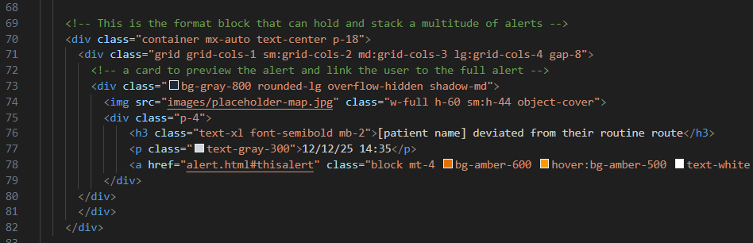
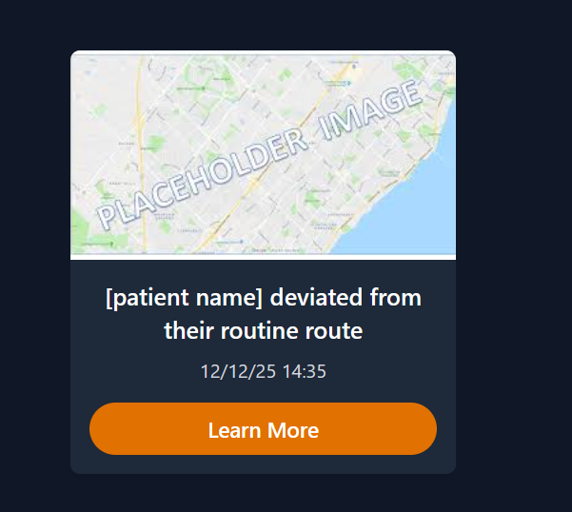
After making the alerts modular:

Link for placeholder map image
https://encrypted-tbn0.gstatic.com/images?q=tbn:ANd9GcTmRoCJ8x1m-Bl6aFakEGrEIzEE4yIblWGVow&s

A prompt I used with an LLM to research a specific topic:
can you give me a breakdown of interacting with hyperlink query strings and how I can use them to load a page with two different blocks of html depending on if a query is valid or not
for example, I am using (<a href="alert.html?id=${alert.id}" >) in my code. Do not produce any code blocks for me, I only want a breakdown of principles that I may find useful to achieve my goal.
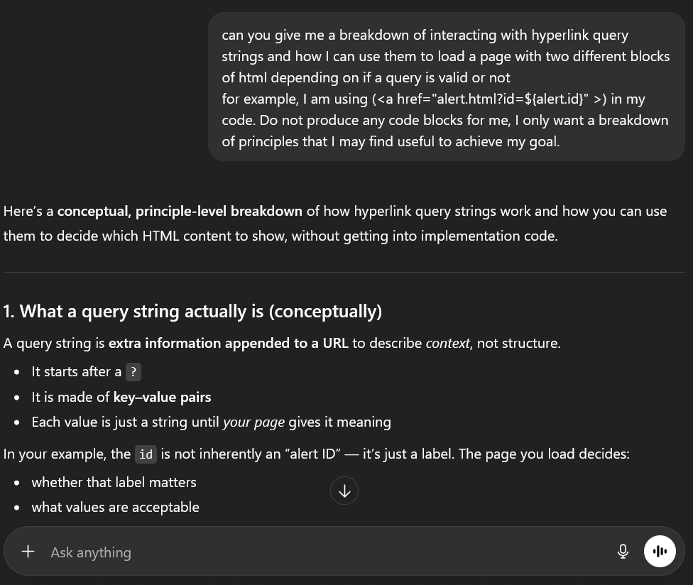
https://chatgpt.com/share/694048da-a810-800a-a7b7-74772518a776

This only covers the first week of website development.
Later website documentation can be found in my report and in the README.md.

